Live Sports Broadcasting Solution

Submitted in partial fulfillment of the requirements of the degree

**BACHELOR OF ENGINEERING IN INFORMATION TECHNOLOGY**

By

|  |  |  |
| --- | --- | --- |
| UID |  | NAME |
| 120IT1108A | : | Pawar Herschel Pravin |
| 120IT1210A | : | Prabhu Yash Rathod |
| 120IT1144A | : | Gajakosh Devdatta Ashok |
| 120IT1034A | : | Mourya Ayush Dilip |

Supervisor

**Prof. Manivannan**



**Department of Information Technology**

**Mahatma Gandhi Mission's College of**

**Engineering & Technology**

**Kamothe, Navi Mumbai - 410 209**

**University of Mumbai**

**(AY 2020-21)**

# **CERTIFICATE**

This is to certify that the Project entitled “Live sports broadcasting solution” is a bonafide work of **Pawar Herschel Pravin (36), Prabhu Yash Rathod (39), Gajakosh Devdatta Ashok (9), Mourya Ayush Dilip (28)** submitted to the University of Mumbai in partial fulfillment of the requirement for the award of the degree of “Bachelor of Engineering” in “Information Technology”

(Prof. ____________)

Supervisor

|  |  |
| --- | --- |
| (Prof. ____________)  Head of Department | (Prof. Dr. Geeta S. Latkar)  Director |

# **PROJECT APPROVAL**

This Project entitled “Live sports broadcasting solution” by **Pawar Herschel Pravin (36), Prabhu Yash Rathod (39), Gajakosh Devdatta Ashok (9), Mourya Ayush Dilip (28)** is approved for the degree of Bachelor of Engineering in Information Technology.

|  |  |
| --- | --- |
|  | Examiners |
|  | 1. Prof Manivannan   (Internal Examiner Name & Sign) |
|  | 1. ______________   (External Examiner Name & Sign) |

Date: 14/12/2021

# **CONTENTS**

**CERTIFICATE** 2

**PROJECT APPROVAL** 3

**CONTENTS** 4

**ACKNOWLEDGEMENT** 5

ABSTRACT 6

**LIST OF TABLES** 7

Introduction 7

SYSTEM PURPOSE 7

SCOPE 7

FEATURES 7

OVEVIEW 8

TECHNOLOGIES USED 8

EXISTING SYSTEM 9

DISADVANTAGES OF CURRENT SYSTEM 9

CHARACTERISTICS OF THE PROPOSED SYSTEM 9

**FLOWCHART** 11

**ER DIAGRAM** 15

**SCREENSHOTS** 16

Login Page 16

Admin Screen 17

Creating A New Tournament 18

Player Lifetime Stats 19

Player Verification Form 20

Admin Player Verification Waiting List 21

Player Verification Details Admin Can See And Has To Verify 22

Team Manager Selecting Team Name 23

Team Manager Inviting Player To Team 24

Player Seeing Their Current Team And Team Invites 25

Scorekeeper Viewing Tournament Details For Tournaments They Can Edit/Add Score To 26

Scorekeeper Viewing Stats For A Match 27

Scorekeeper Adding Stats For A Match Inning 28

**CONCLUSION** 29

**BIBLIOGRAPHY** 30

**FUTURE SCOPE** 31

# **ACKNOWLEDGEMENT**

The success and final outcome of this project required a lot of guidance and assistance from many people and we are extremely fortunate to have got this all along the completion of our project work. Whatever we have done is only due to such guidance and assistance and we would not forget to thank them.

It is matter of great pleasure for us to submit the project report on “Live sports broadcasting solution”, as a part of our curriculum.

First and foremost, we would like to thank to our Director **Dr. Geeta S. Latkar**, for giving us an opportunity to do the project work. We would like to thank our H.O.D. and teachers for the valuable guidance and advice. They inspired us greatly to work in this project. Their willingness to motivate us contributed tremendously to our project.

And last but not the least a special thanks goes to my team members, who helped me to assemble the information and gave suggestions to complete our project.

# ABSTRACT

Cricket league management software is a program which is developed or implemented in Java. This project separates the it’s user types into 4 groups, namely admin, team manager, player and score keeper. This project is helpful for cricket players who want to track their statistics. Admin manages and runs tournaments. Team manager decides which tournaments to enter. Score keeper enters the statistics like runs, wickets, balls, 6s, etc. The lifetime data is automatically calculated and shown to the player in their home screen.

# **LIST OF TABLES**

## Introduction

### SYSTEM PURPOSE

The purpose of our software is to store data (for e.g., the numbers of runs a player has done or how many wickets a player has taken) and then present it to the players. This not only saves time by not having to do all the work manually but also makes it easier as a verified 3rd party can fill in the data so its safer. The players can concentrate on working hard and practicing for their matches instead of maintaining databases. Our software separates the roles so work is done more efficiently.

### SCOPE

The scope of this project is very broad as similar system can be used for other sports like football or basketball as well. Few of them are:

* It can be used for small associations which can’t afford big systems which are already available
* It should be easy to operate
* It should use unique identification number for identification (in this case we used Aadhar number)
* It should be more secure AND faster than traditional method i.e., doing it by hand

### FEATURES

* Secure
* Easy to use
* Reliable
* Efficient division of work

## OVEVIEW

The software has the following user types and the functions available to them

1. Admin
   1. Create tournaments
   2. Edit details for tournaments
      1. For both upcoming and finished tournaments
   3. Verify players
2. Team manager
   1. View lifetime stats for the members of the team
   2. Invite players to their team
   3. Join upcoming tournaments
      1. This can be only performed when the team has at least 10 players
3. Score keeper
   1. Add statistics for the tournament matches
4. Player
   1. View match info
   2. Send information for verification
   3. View lifetime stats
   4. Accept/deny requests for joining team
      1. If the player is already in a team, then show the name of the team

## TECHNOLOGIES USED

1. Java
   1. JavaFX for UI (scenes, buttons, pagination, etc.)
      1. CSS for changing how the UI members look
2. MySQL
   1. Database for storing all the information

## EXISTING SYSTEM

You either need to do it with paper and pen or use websites like Sportsplus (<https://sportsplus.app/cricket>) or Playpass (<https://playpass.com/sports-software/cricket-management>) both of which require some sort of subscription or payment

## DISADVANTAGES OF CURRENT SYSTEM

The current system is very time consuming

It requires the player to manually remember the match details and then sum it themselves

The results might be wrong if the player inputs some data wrong and then they need to start all over again

## CHARACTERISTICS OF THE PROPOSED SYSTEM

Our software has the following advantages over current system

It requires less time and is more efficient

The player only needs to register, then verify and finally accept the team invite from their team manager

The score manager has to add the match stats so the player doesn’t need to do anything

If there is a mistake/typo in the input data then the responsible score keeper can just edit the match stats and the lifetime stats for the player will change automatically

# **FLOWCHART**













# **ER DIAGRAM**

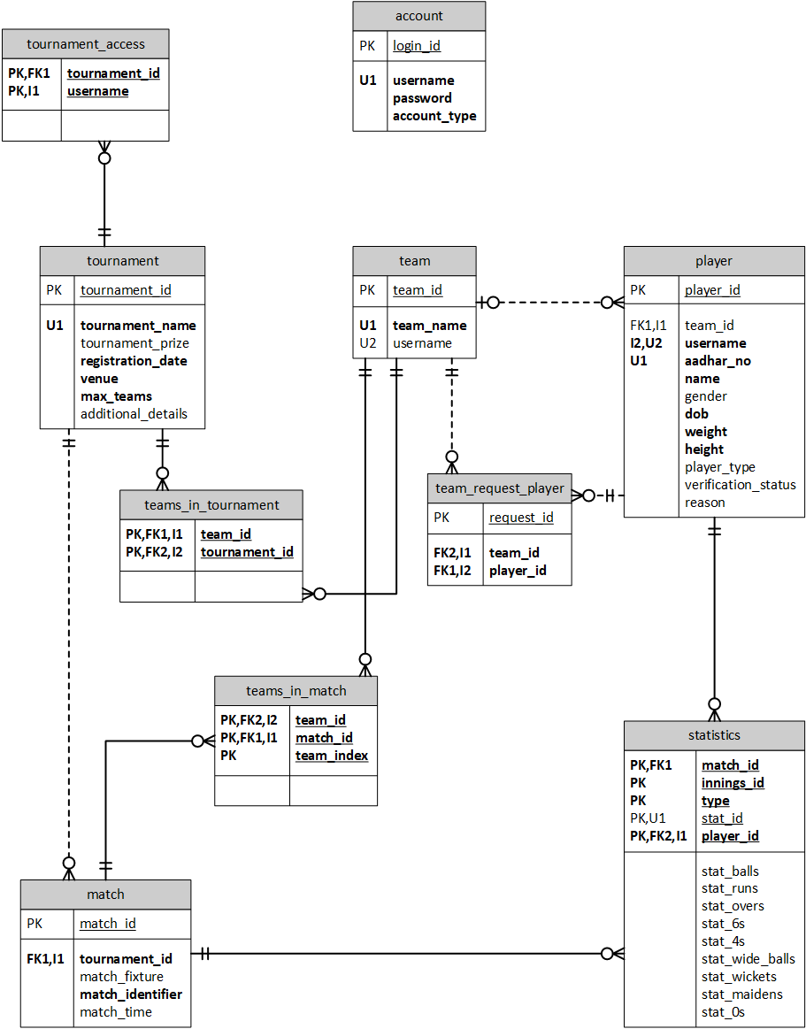

# **SCREENSHOTS**

## Login Page

Login Screen


## Admin Screen

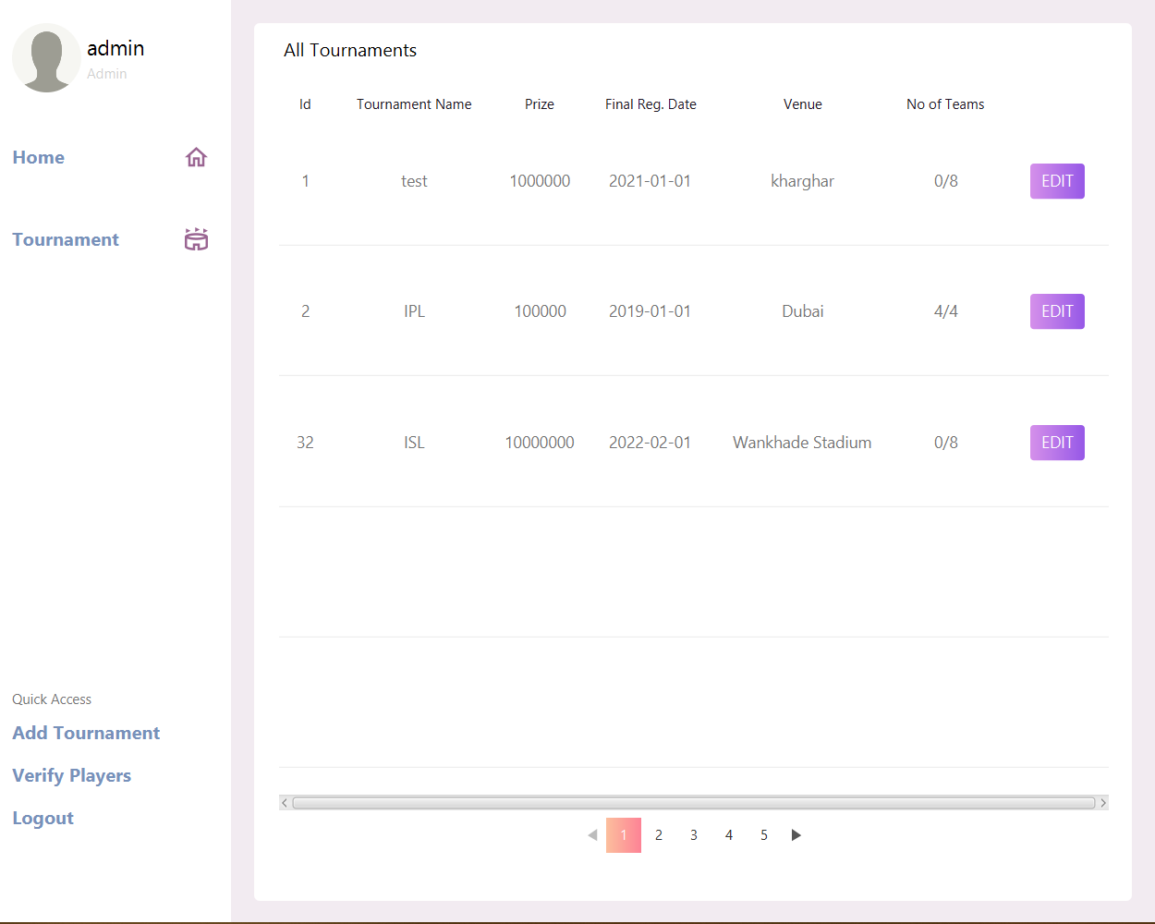

## Creating A New Tournament

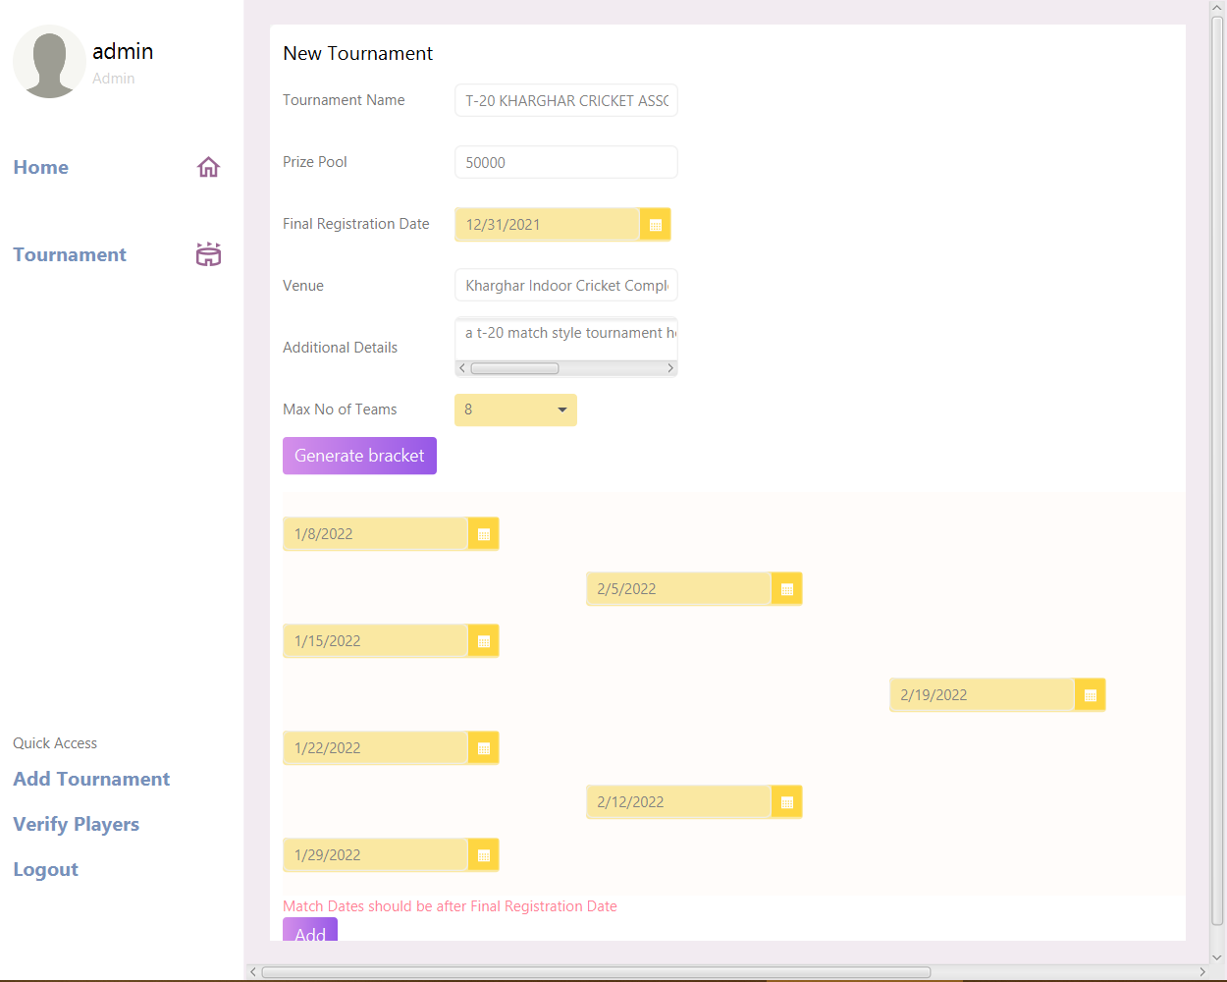

## Player Lifetime Stats

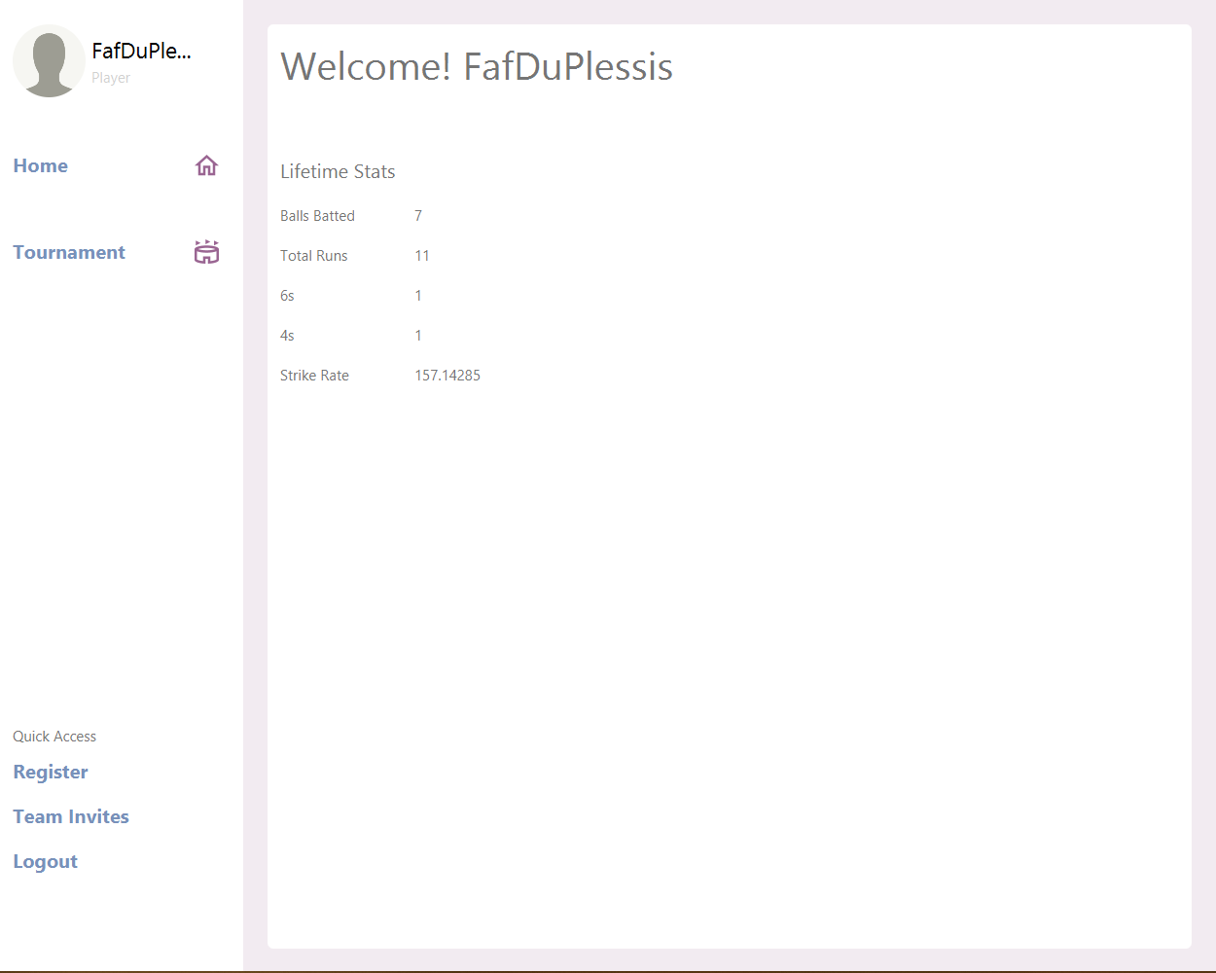

## Player Verification Form

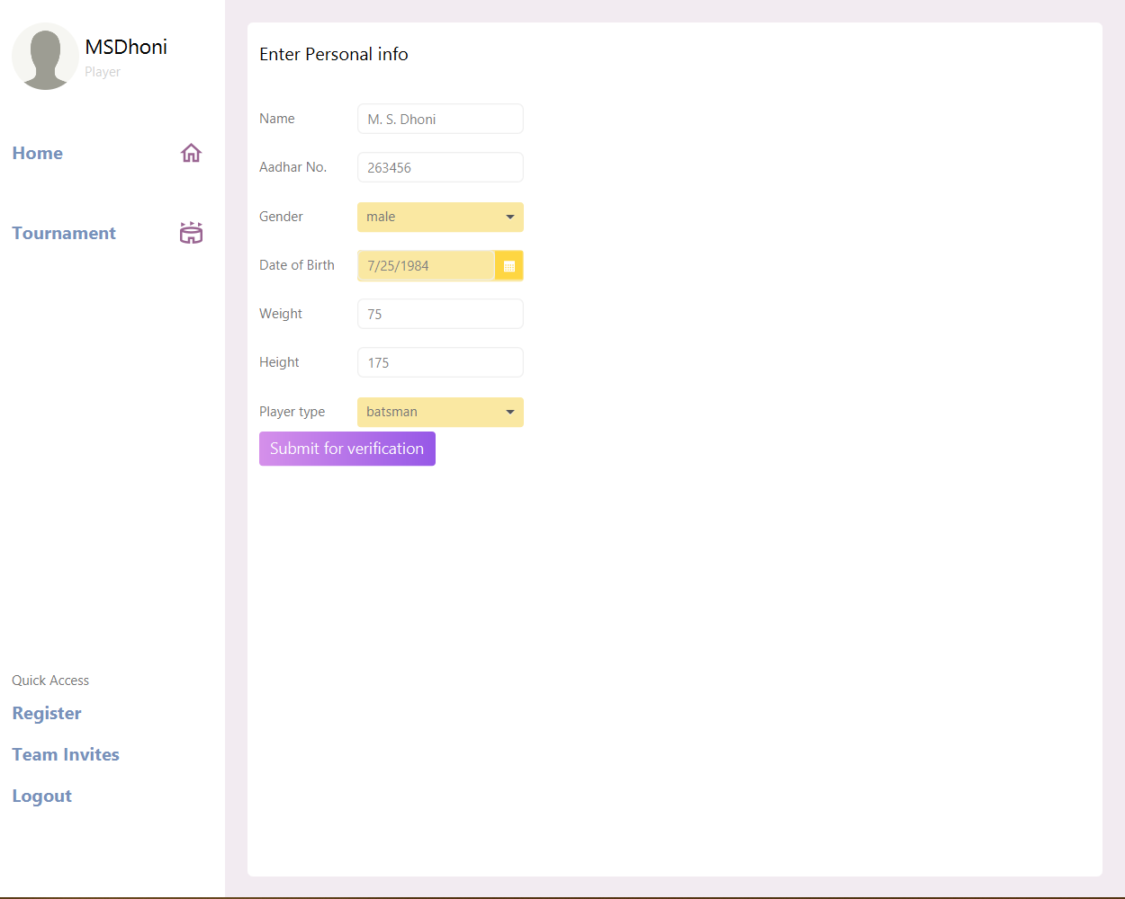

## Admin Player Verification Waiting List

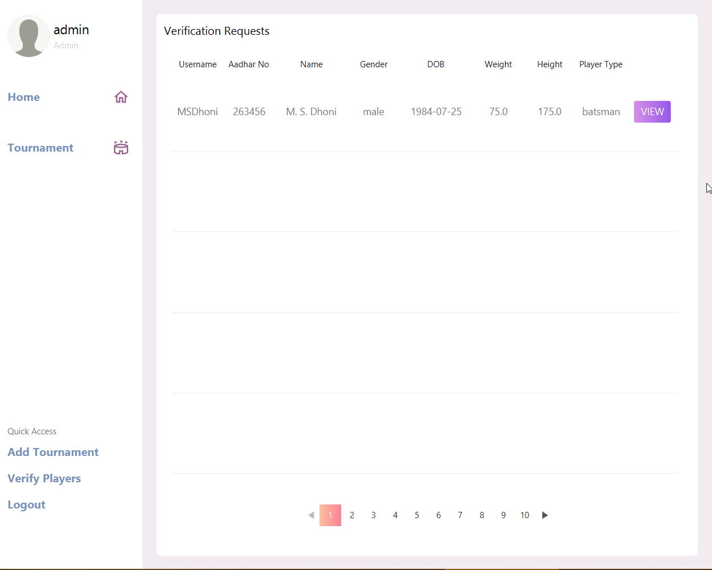

## Player Verification Details Admin Can See And Has To Verify

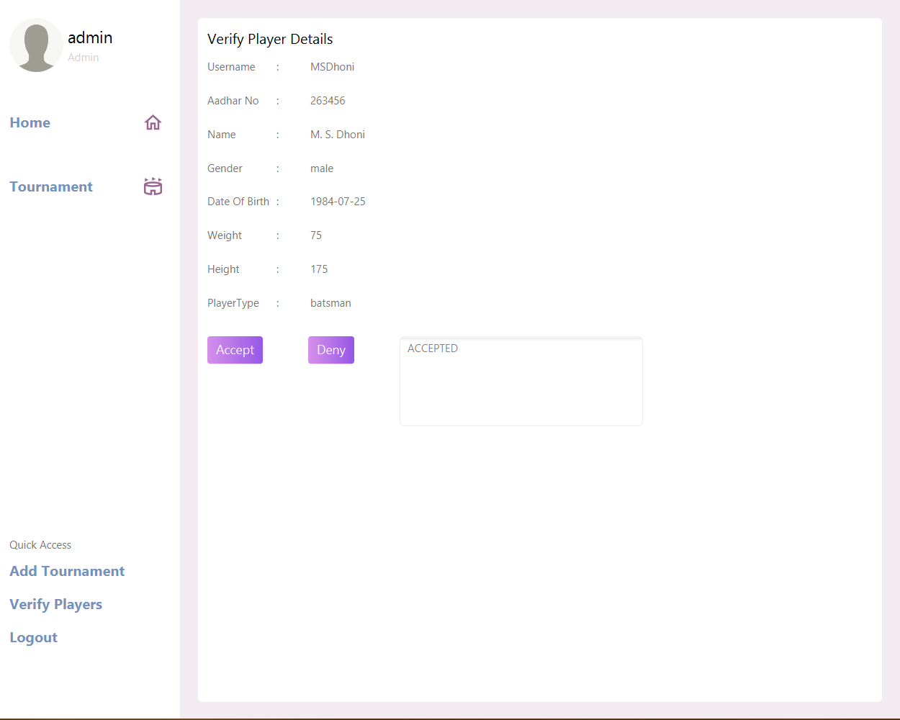

## Team Manager Selecting Team Name

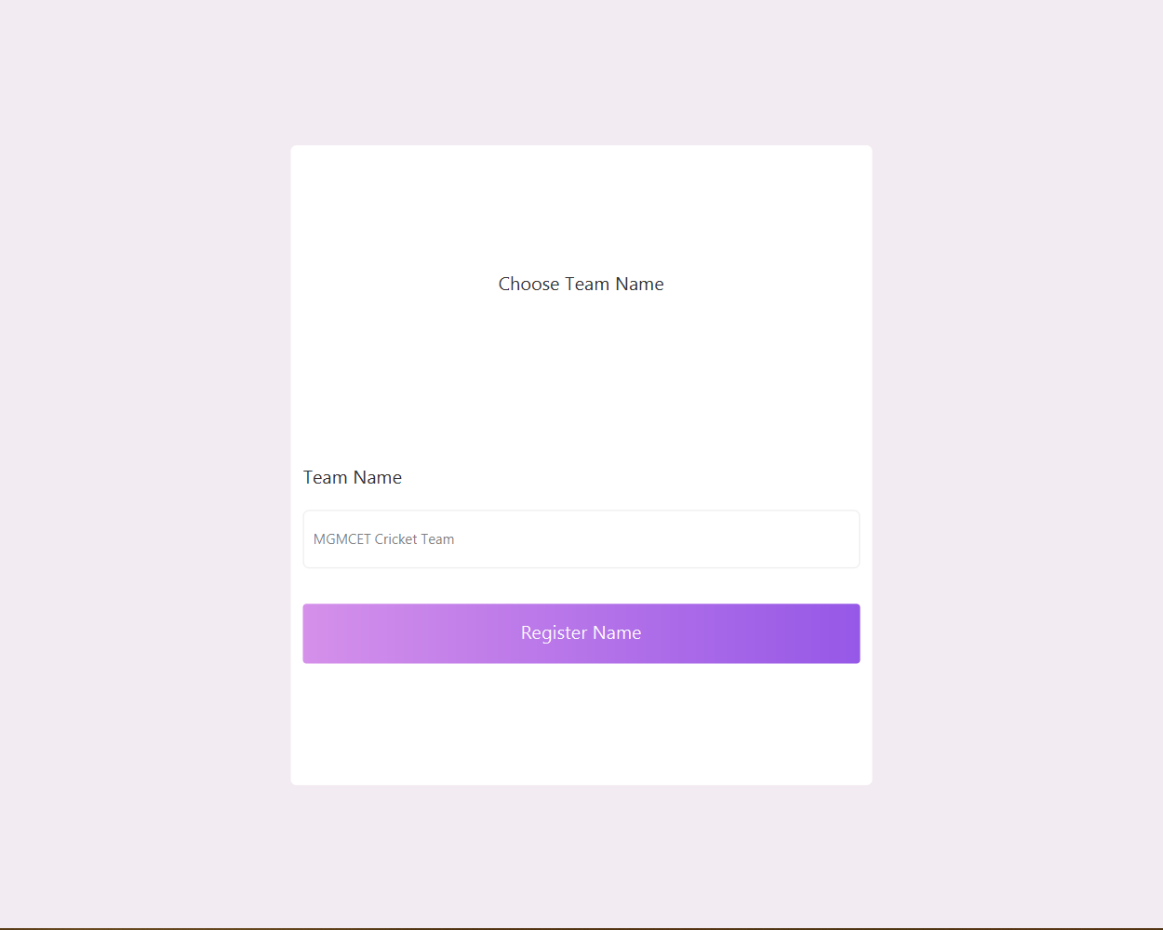

## Team Manager Inviting Player To Team

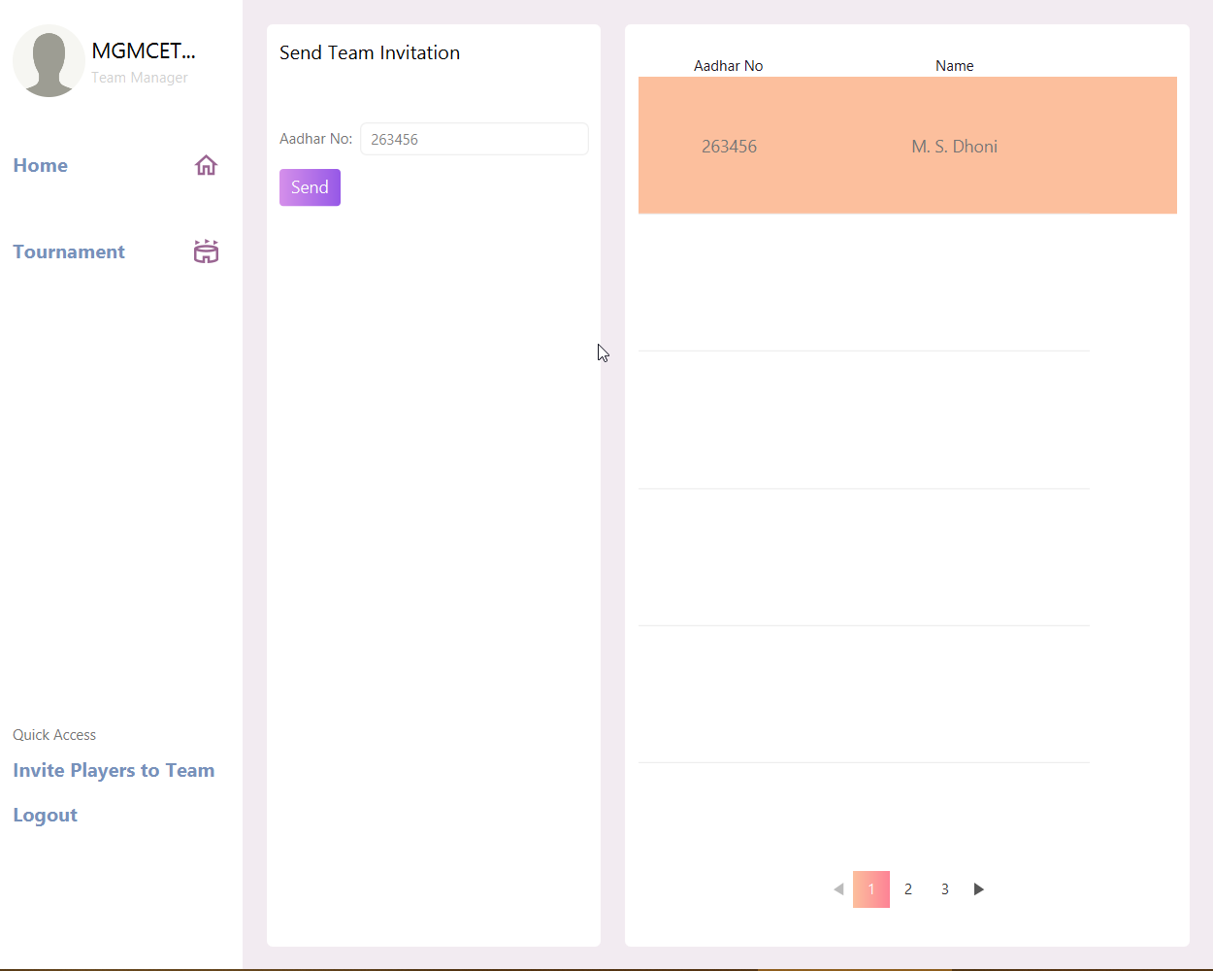

## Player Seeing Their Current Team And Team Invites

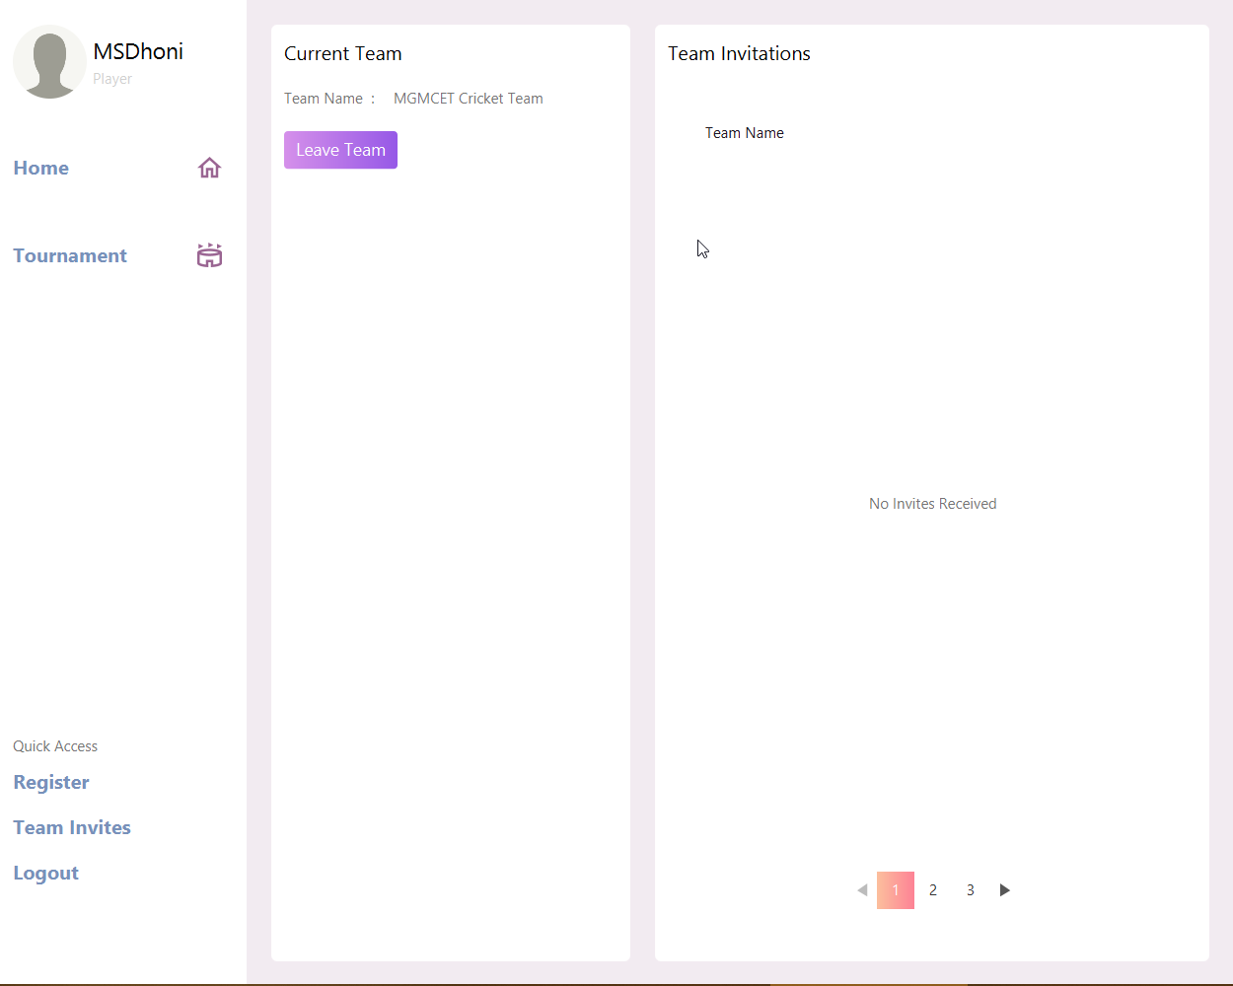

## Scorekeeper Viewing Tournament Details For Tournaments They Can Edit/Add Score To

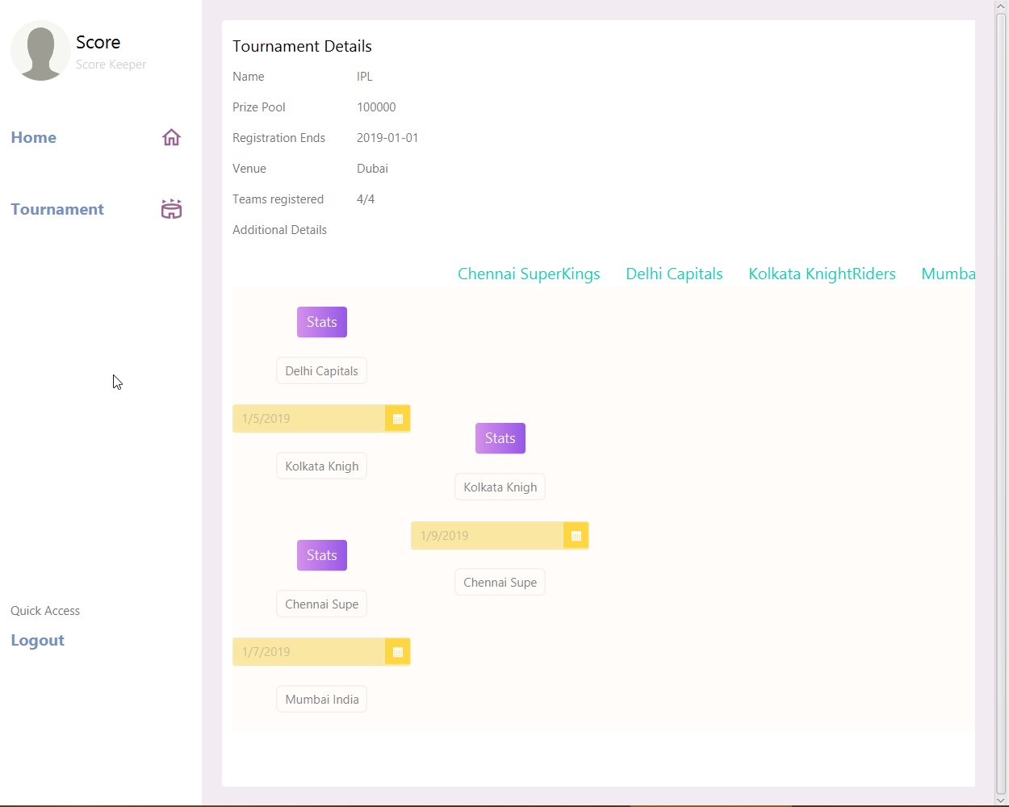

## Scorekeeper Viewing Stats For A Match

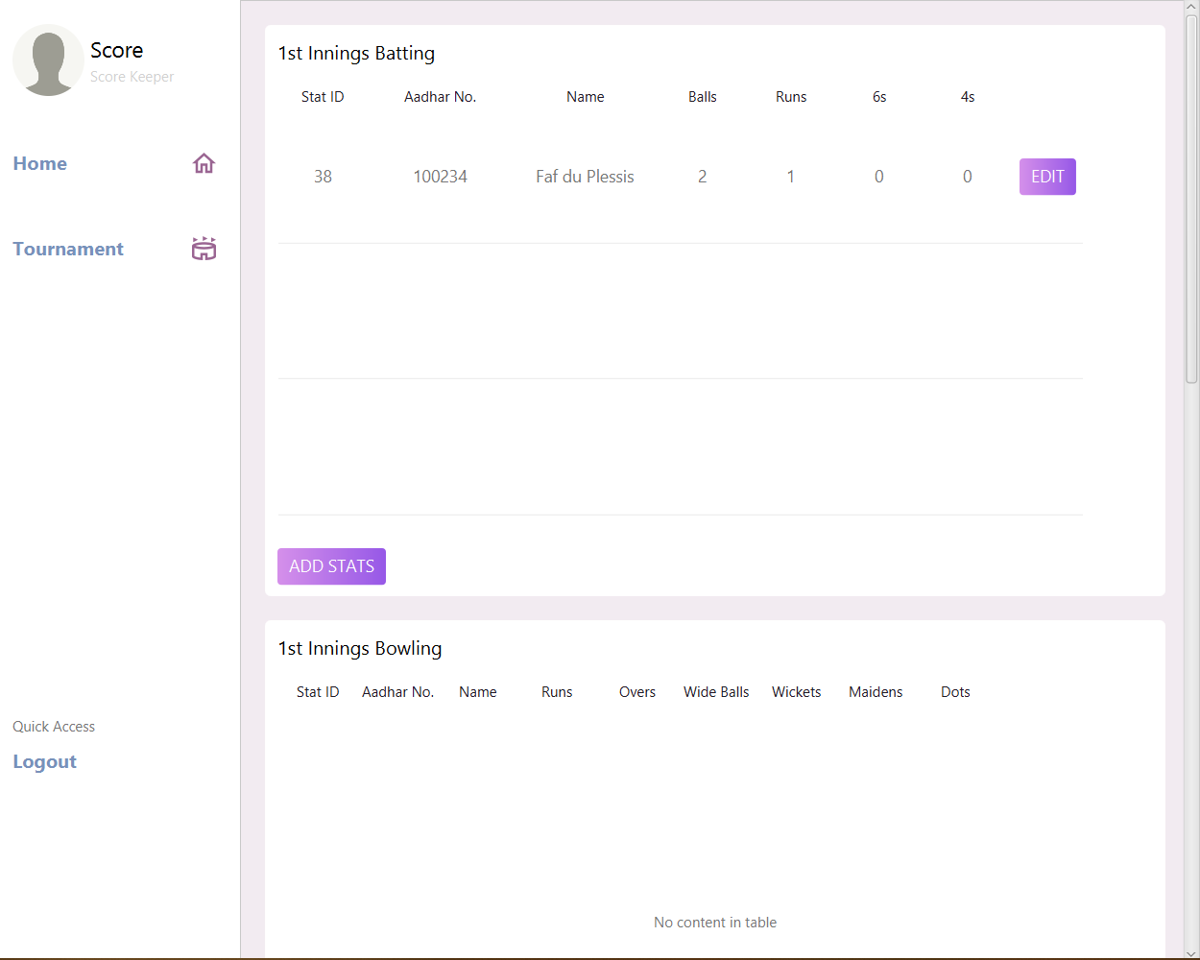

## Scorekeeper Adding Stats For A Match Inning

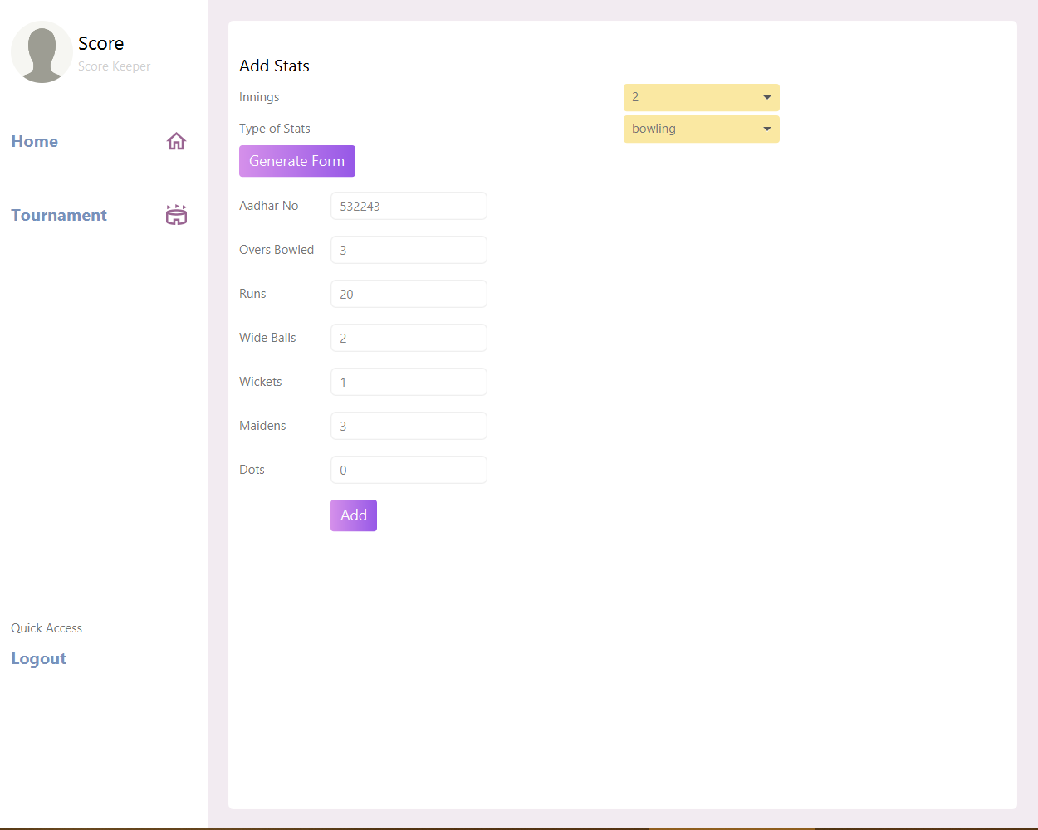

# **CONCLUSION**

The cricket league management software is developed using java and filly meets the objectives of the system for which it was developed. The system has reached a steady state where all bugs have been squashed. The system is operated at a high level of efficiency and all the teachers and users associated with the system understand it’s advantages. The system solves the problems it was intended to solve for the required specification.

# **BIBLIOGRAPHY**

B., B. P., & Bhakti, R. (2019). *Java book.* Tech-Neo Publications LLP (1 January 2019).

Hamdare, S., & Sen, S. H. (2016). *Database Management System.* Vikas.

*JavaFX GUI Course ☕ (𝙁𝙧𝙚𝙚)*. (2021, March 22). Retrieved from YouTube: https://www.youtube.com/watch?v=9XJicRt_FaI

JavaTPoint. (n.d.). *Java JDBC Tutorial*. Retrieved from JavaTPoint: https://www.javatpoint.com/java-jdbc

JavaTpoint. (n.d.). *Java Tutorial*. Retrieved from JavaTPoint: https://www.javatpoint.com/java-tutorial

# **FUTURE SCOPE**

Our project can be expanded in multiple ways like

1. We would like to add visual representation of data like pie charts and bar graphs for match stats and lifetime stats.
2. We would also like to add the ability for the user to change their profile picture.
3. The program should be able to sync across multiple devices
4. It should be usable as an API for websites and official tournaments
5. The security should be increased further by using hashing the passwords and adding conditions for the password
6. It would be useful if we could send email and an SMS for events like being invited to a team, verification being accepted/denied, 24 hours before a match, etc.
7. The ability to store more types of sports like basketball, hockey, table tennis, etc.